Christkindlmarkt Half Pot Instructions-2025
Zeffy (online) purchase
- If wanting to purchase half pot tickets online, individuals need to scan the QR code on the flyer at the greeter station or around the market sites. QR code is also below.


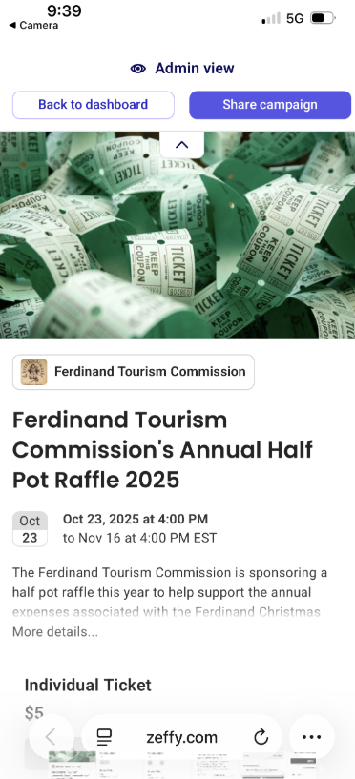
- Once QR code is scanned, you will be taking to a site on your phone looking as below. Choose what ticket option/qty you want ($5 for 1 or $20 for 5). You will have to input quantity for each ticket option. If you want to purchase $40 in tickets, you would type quantity of 2 for the ticket bundle option. Follow steps below.
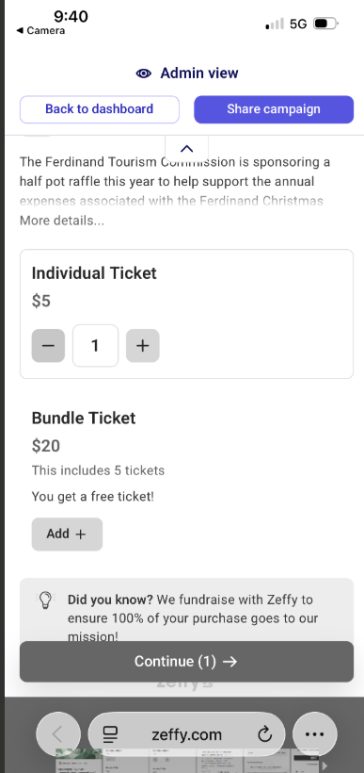
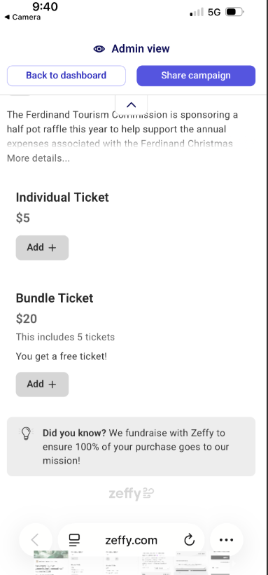

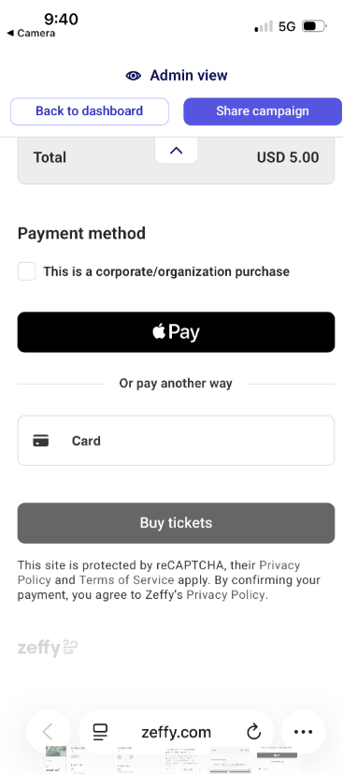
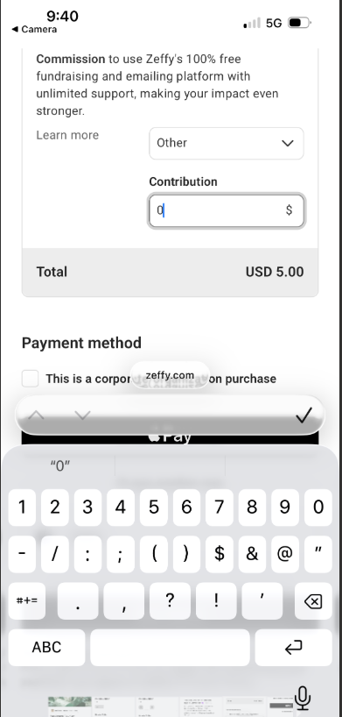
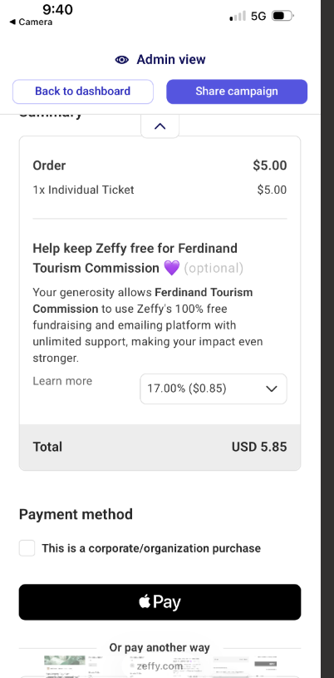
This is NOT a fee! Click drop down and choose 0%. It is a donation to Zeffy to help keep free but not required. They do NOT have to pay.
Choose payment method.
Choose other in drop down and type 0 in for contribution to NOT pay donation to Zeffy.

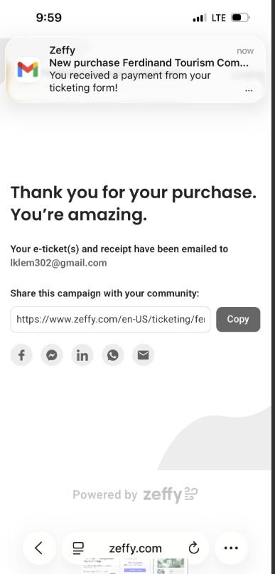
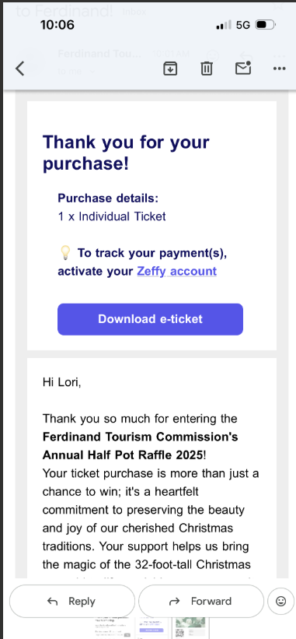
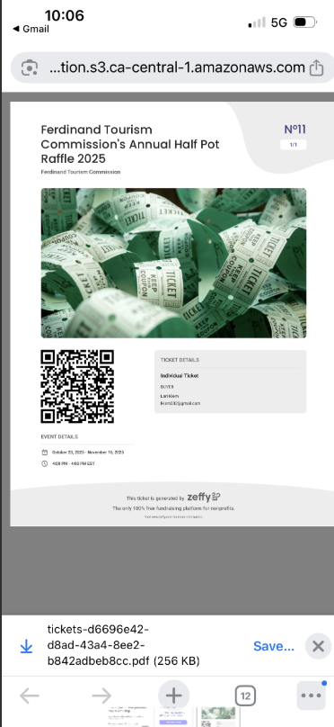
Once payment completed, you will receive receipt via email.
E-ticket download but not required
Can download e-ticket if wanting but NOT required

CASH OPTION
- If wanting to pay cash, same pricing applies. Cash option is ONLY available at Junior High Practice gym by the greeter booth. They will be provided a ticket as a receipt plus they need to fill out a ticket for us to enter (duplicate ticket number rolls). Must fill out Name and Number on ticket submitted to us.
- Winner will be drawn after 4 PM on 11/16 and notified promptly.

