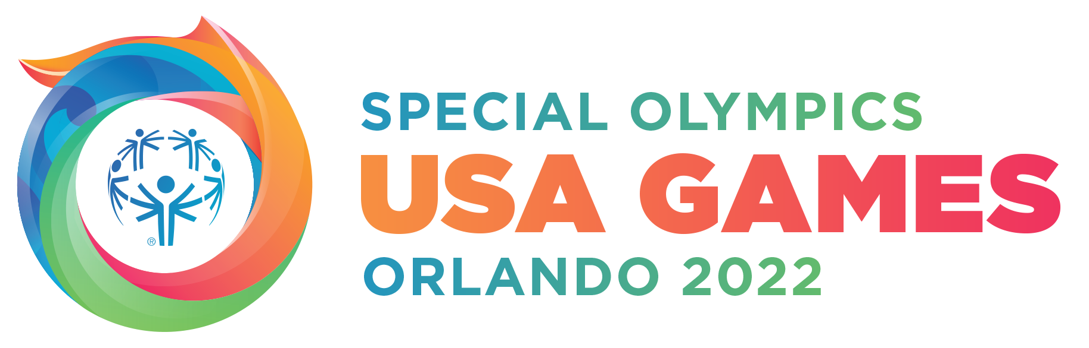

2022 Special Olympics USA Games
Fast Facts – At a Glance

Location & Dates
The 2022 Special Olympics USA Games is scheduled for June 5-12, 2022 in Orlando, Florida.

By The Numbers
Over 4,300 athletes
Over 1,300 coaches
Over 10,000 volunteers to fill over 20,000 shifts
Over 125,000 families, friends and spectators
67 Delegations from the United States and Caribbean

Sports (19 Olympic-style team and individual sports)
Athletics (track & field), basketball, bocce, bowling, cheerleading, equestrian, flag football, golf, gymnastics, open water swimming, powerlifting, soccer, softball, stand up paddleboard, surfing, swimming, tennis, triathlon and volleyball.
More info: https://www.2022specialolympicsusagames.org/sports

Venues
Walt Disney World Resort (Host Partner)
ESPN Wide World of Sports (Main Location)
Exploria Stadium (Opening Ceremony)
Other sporting facilities across Orlando include Boardwalk Bowl Entertainment Center, Disney’s Typhoon Lagoon Water Park, Lake Minneola Waterfront Park, Lucky’s Lake, Orange County National Gold Center, Osceola Heritage Park, Rosen Aquatic Center and USTA National Campus.
More info: https://www.2022specialolympicsusagames.org/venues

Partners
Presenting Partner: Jersey Mike’s
Host Partner: Disney
Global Broadcast Partner: ESPN
Platinum Partners: Bank of America, Coca-Cola, Experience Kissimmee, Fanatics, Jabil, Orange County, Orlando Health, Publix
Gold Partners: Gallagher, WWE
Silver Partner: Ron Jon Surf Shop
USA Games Media Partner: Westwood One, WFTV
Professional Services Partners: ATS, Dex Imaging, Eleiko, Managed Services Group, McNatt Law Firm, P.A., Publicis, MTM Recognition
More info: https://www.2022specialolympicsusagames.org/about/sponsors

Games Ambassadors
For more on the A-list roster of more than 40 athletes and entertainment celebrities, visit https://www.2022specialolympicsusagames.org/about/2022-game-ambassadors.

Motto/Hashtag
We all have reasons to shine. For Special Olympics athletes, one reason is sport. They display remarkable abilities not only on the field, but in all areas of life. By celebrating their dedication and perseverance on and off the playing field, we become champions for a more inclusive world. A world where we all Shine As One. #ShineAsOne

Get Involved
To learn more about how you can get involved with 2022 Special Olympics USA Games, visit
https://www.2022specialolympicsusagames.org/get-involved

To donate to the 2022 Special Olympics USA Games, visit
https://www.2022specialolympicsusagames.org/get-involved/donate

To apply to be a volunteer for the 2022 Special Olympics USA Games, visit
https://www.2022specialolympicsusagames.org/get-involved/volunteer

For more information on sponsorship opportunities with the 2022 Special Olympics USA Games, visit https://www.2022specialolympicsusagames.org/get-involved/sponsor

To join the 2022 Club for Special Olympics USA Games visit
https://2022club.2022usagames.org/event/202cludra/

Stay Connected
To stay connected, follow 2022 Special Olympics USA Games on
Instagram: @specialolympicsusagames
Facebook: @SpecialOlympicsUSAGames
Twitter: @2022USAGames

###

