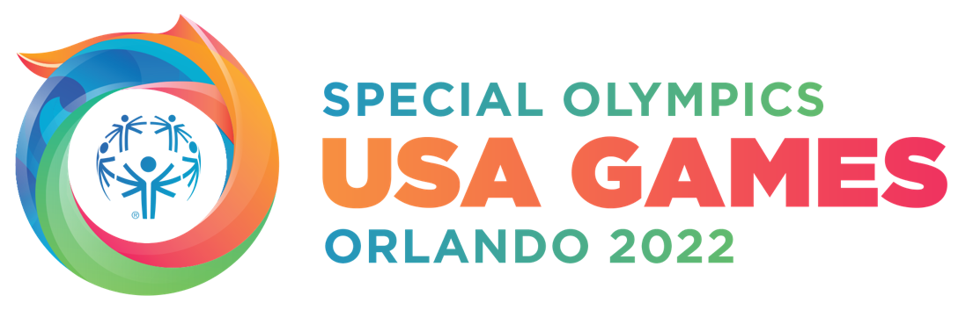
The LARGEST Special Olympics USA Games in History Gets Even Bigger for 2022
The 2022 Special Olympics USA Games announced Exploria Stadium as the Opening Ceremony venue, introduced additional celebrity Ambassadors, including Academy Award winner Matthew McConaughey, welcomed new corporate partnerships, highlighted Florida’s Governor and First Lady as honorary co-chairs, and announced the launch of the USA Games online store, powered by Fanatics.

ORLANDO, Fl. (January 27, 2021) – Today, the 2022 Special Olympics USA Games, presented by Jersey Mike’s Subs, announced new highlights for the USA Games, which are scheduled to be held in Orlando, Florida, June 5-12, 2022. During a 30-minute virtual event (click to view program), which streamed on Facebook and YouTube, USA Games President & CEO Joe Dzaluk outlined big news around Florida’s largest-ever humanitarian event.

Today’s digital event showcased Exploria Stadium, which the USA Games introduced as the location of the Opening Ceremony. The Opening Ceremony will broadcast on the ESPN and ABC family of networks and is scheduled for June 5, 2022.

Florida Governor Ron DeSantis and First Lady Casey DeSantis were welcomed as honorary co-chairs of the 2022 Special Olympics USA Games.

Four new celebrity Ambassadors were introduced, including Matthew McConaughey, Tyra Banks, Annika Sörenstam and Kaká. They join more than 38 celebrities and athletes such as Lin-Manuel Miranda, Jimmy Kimmel and Charli D’Amelio who have committed to lending their voices in support of the Games. (Full List).

Matthew McConaughey is an Academy Award-winning actor, New York Times best-selling author, philanthropist and founder of the just keep livin Foundation.

Tyra Banks is an entrepreneur, supermodel and television personality. She was the first female model to appear on the cover of GQ magazine and the first black woman to appear on the cover of Sports Illustrated Swimsuit Issue. She was also twice named to TIME magazine’s most influential people list.

Annika Sörenstam has won 90 worldwide golf tournaments, including 72 on the LPGA Tour and 10 majors. She was named Player of the Year eight times and is regarded as one of the best golfers in history.

Kaká is a Brazilian soccer legend and 1 of 8 players in the world to win the FIFA World Cup, the UEFA Champions League and the Ballon d'Or (world's best player award). He has been a UN World Food Programme Ambassador since 2004.

During the virtual event, Dzaluk introduced the following partnerships:
- Platinum Partner, Jabil Inc., a global manufacturing solutions provider, based in St. Petersburg, Florida.
- Platinum Partner, Experience Kissimmee (Osceola County), the Official Destination Marketing Organization for the 2022 USA Games.
- Gold Partner, Gallagher, the Official Community Insurance Broker of the 2022 USA Games.
- Ron Jon Surf Shop and Surfing’s Evolution & Preservation Foundation, who together will present the sport of surfing at the USA Games.

ESPN’s Kevin Negandhi joined via video to share in celebrating the Special Olympics athletes, and highlighted ESPN’s relationship with Special Olympics and their support as the Global Broadcast Partner of the 2022 Special Olympics USA Games.

WWE’s Kayla Braxton and Big Show, an Ambassador for the Games, celebrated the long-standing partnership between USA Games and Special Olympics. WWE is the Presenting Partner of the sport of powerlifting at the USA Games, and through their significant partnership will offer support to the Games in the form of promotions, a one-of-a-kind content series and through appearances by WWE Superstars.

Also introduced was Fanatics, the Exclusive Merchandise Partner, who joined via video to announce the opening of the USA Games online store (shop.2022usagames.org), powered by Fanatics, as well as a 15% off code in honor of the store launch, which can be used now until February 14, 2021. (Promo Code: INSPIRE15)

“We’ve always said that this will be big, and now with amazing support from Ambassadors and partners, we’re able to start celebrating how big this will be,” said Joe Dzaluk, President & CEO of the 2022 Special Olympic USA Games. “We are 16-months away from the Games, and now more than ever, we’re looking forward to putting the spotlight on our amazing athletes, spreading the message of inclusion and inspiring a new generation of Special Olympics supporters.”

To learn more about the 2022 Special Olympics USA Games visit www.2022USAGames.org. Follow the organization on Facebook, Instagram and Twitter.

About the 2022 Special Olympics USA Games
The 2022 Special Olympics USA Games is scheduled for June 5-12, 2022 in Orlando, Florida. Jersey Mike’s Subs is the Presenting Partner and Walt Disney World Resort is host. During this magical week, more than 5,500 athletes and coaches from all 50 states and the Caribbean will travel to Florida to unite in one of the country’s most cherished sporting events. The USA Games is hosted once every four years and showcases 20 Olympic-style team and individual sports and 30 events throughout the week including forums and VIP receptions. Website: www.2022usagames.org

###

