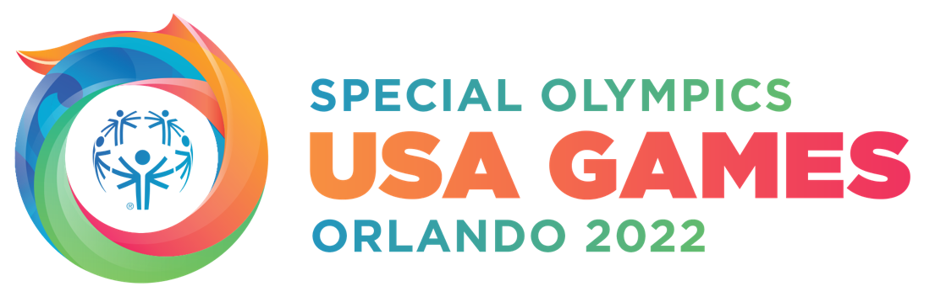
2022 Special Olympics USA Games Celebrate the One-Year-Out Countdown with Major Announcements
The USA Games introduced Academy Award winner Brie Larson and Golden Globe winner Shonda Rhimes as Games Ambassadors, announced corporate partners and surprised Special Olympics Florida athletes with a “You’re Going to the Games” announcement, as well as made a public call-to-artists for the Cauldron Arts Project

ORLANDO, Fla. (June 8, 2021) – Today, as part of a week-long One-Year-Out celebration, the 2022 SpecialOlympics USA Games, presented by Jersey Mike’s Subs, introduced new celebrity Ambassadors, sponsors, and projects for the USA Games, as well as offered a surprise moment for Special Olympics Florida athletes at Exploria Stadium, the location of the Opening Ceremony. The USA Games are scheduled in Orlando, Fla., June 5-12, 2022.

Highlights and announcements included:

Introducing Two New Celebrity Ambassadors
To date, there are 45 Ambassadors who have agreed to lend their voices to the Games in support of SpecialOlympics athletes, five of whom are Academy Award winners. The impressive line-up includes actors Lin-Manuel Miranda and Tiffany Haddish, as well as sports legends Chris Evert and Grant Hill, to name a few. During the week-long One-Year-Out celebration, Ambassador highlights will include Matthew McConaughey and Ja Morant surprising athletes and letting them know “You’re going to the Games.” The Games also welcomes two new Ambassadors:

Brie Larson, Academy Award-winner, made cinematic history as Marvel’s first female superhero lead in Captain Marvel. In 2020, she won an Emmy Award for Outstanding Original Interactive Program for co-producing “The Messy Truth VR Experience”, a VR series designed to promote empathy. She is a vocal advocate of equity and inclusion.

Shonda Rhimes Shonda Rhimes is an award-winning television creator, producer and New York Times best-selling author. She is also the CEO of Shondaland, the global media company that encompasses storytelling through brand partnerships, merchandise, and content for film, streaming, audio, digital and editorial.

Welcoming New Corporate Partnerships
The Games is presented by Jersey Mike’s Subs, hosted by Disney and made possible through the support of top companies. The Games announced the following new partners who have pledged their support of SpecialOlympics athletes:
- Platinum Partner, The Coca-Cola Company, the Official Beverage Provider of the 2022 USA Games
- Platinum Partner, Bank of America, the Official Bank Partner of the 2022 USA Games
- Gold Partner, Academy Bus, the Official Bus Transportation Company of the 2022 USA Games
- Gold Partner, Lions Club International Foundation, Service Partner of the 2022 USA Games and Team Florida
- Presenting Member of the 2022 Club, Echelon Fitness, a connected fitness company

Surprising Florida Soccer Athletes: “You’re Going to the Games”
The USA Games surprised a Special Olympics Florida soccer team, informing the team they have qualified to compete in the USA Games next June. The Special Olympics athletes were congratulated by both Orlando City and Orlando Pride team members via video message.

Proclamation Announcement From City of Orlando Mayor
In addition to the one-year out festivities, the City of Orlando Mayor, Buddy Dyer proclaimed June 5 – 12, 2021 as “The 2022 Special Olympics USA Games – Shine as One Week.” Orlando is a welcoming destination that is committed to compassion and kindness and this official proclamation allows the local community and beyond to build excitement for the USA Games and creates a week for everyone to shine as one.

Announcing The Cauldron Arts Project
The Games launched the Cauldron Arts Project, which invites artists from across the country to submit to be the official USA Games cauldron artist. In collaboration with Greater Orlando Sports Commission, the USAGames has assembled Special Olympics athletes and Orlando arts leaders to create the selection process and review the submissions. The Cauldron is lit by the Flame of Hope during Opening Ceremony, which is scheduled for June 5, 2022, and will be broadcast on the ESPN and ABC family networks. Following the Games, the Cauldron will find a permanent home in Orlando.

“The 2022 Special Olympics USA Games is bringing people together to shine as one. We see it in the excitement of our community, and in the support that the biggest brands and most well-loved celebrities provide for our athletes,” said Joe Dzaluk, President & CEO of the 2022 Special Olympic USA Games. “During the next few months, Special Olympics Programs around the country and the Caribbean will be sharing the magical moment of letting athletes know that they are coming to Orlando in June 2022. This is a history-making opportunity for the nation to shine as one for Special Olympics.”

To learn more about the 2022 Special Olympics USA Games visit www.2022USAGames.org. Follow the organization on Facebook, Instagram and Twitter.

About the 2022 Special Olympics USA Games
The 2022 Special Olympics USA Games is scheduled for June 5-12, 2022, in Orlando, Fla. Jersey Mike’s Subs is the Presenting Partner and the event is hosted by Disney. During this magical week, more than 5,500 athletes and coaches from all 50 states and the Caribbean will travel to Florida to unite in one of the country’s most cherished sporting events. The USA Games is hosted once every four years and showcases 19 Olympic-style team and individual sports and 30 events throughout the week including forums and VIP receptions. Website: www.2022usagames.org

###

